Exercises to share with young children in community groups to discuss waste reduction and a Waste-Free Lifestyle
Prepared by: Sponsored by:

Below offers various activities, for instance, for a community group, a place of worship, a cultural group, neighbourhood group or a summer camp. TREA also has an activity book for various ages. Several exercises for teens are in our Grade 8 curriculum module.
YOUNG CHILDREN
This exercise involves collecting items deemed as waste such as egg cartons and toilet paper rolls, and then turning them into plant pots. The goal is to think about our waste differently and to find ways to repurpose it. Use plant seeds from native wildflowers recommended to grow here. This project leads to discussion about waste and possibly conversations about pollinators.
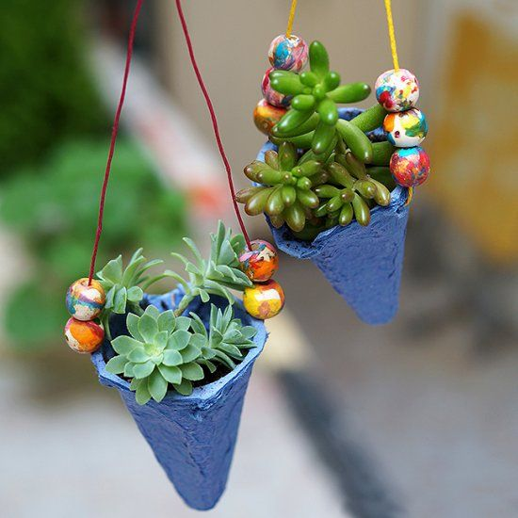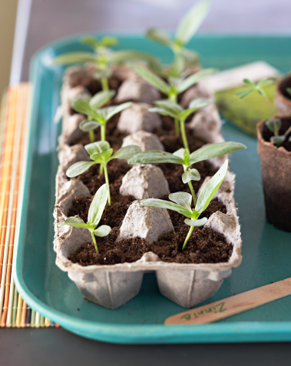
Create a Pictionary sort of items that go into the recycling bin. Draw each picture on a white board and have participants guess what the item is (a charades-inspired word-guessing game). Have a discussion evolve from the exercise on - What does recycling accomplish? Does your family recycle? Review your garbage calendar and note everything that can be recycled.
Cut up 3 pool noodles (4 different colours) into 9” lengths and then label the lengths with different types of items that are either available to compost, recycle, reuse or waste. Have 4 bins available as well and divide children up into 2 teams and give each team the same number of noodles. Have children complete a relay race from a distance to put a noodle from each child into the correct bins. Discuss what might be done with any items that have to go into the waste bin to allow more usage. Describe what a circular economy is.
This activity involves using moist paper towels to germinate wildflower seeds. This exercise can create discussions on how the paper towel can be safely composted, the importance of composting, and possibly how the wildflowers will aid pollinators. Other topics include soils, gardens to hold the soil, other recyclable containers and alternatives to buying plastic plant pots.
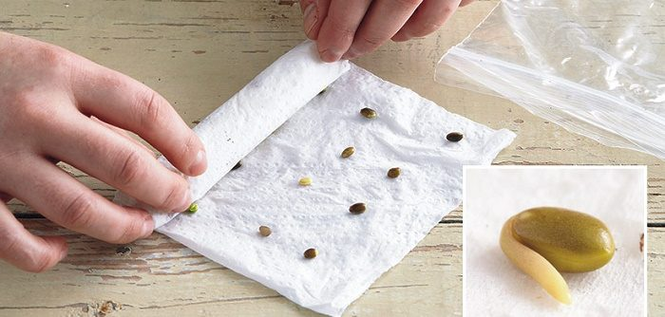
Create animal sculptures made from recycling box materials gathered earlier. Discuss options.
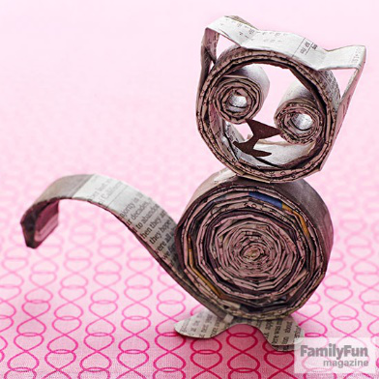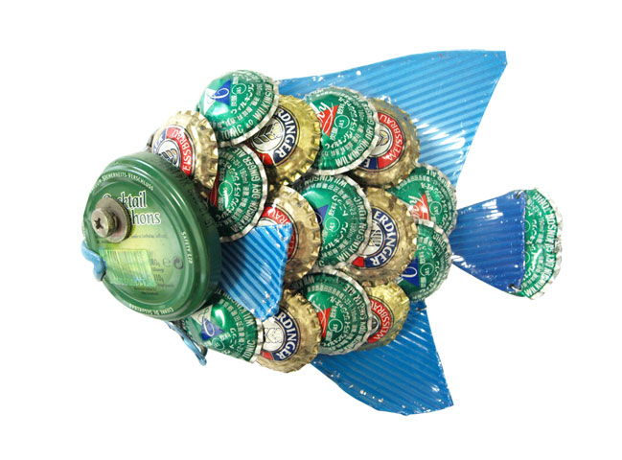
Organize an animal art show with children being given a picture of an animal so they can add colour, fabric or depth to the picture. Discuss the importance of habitat and impacts of humanity dumping waste where animals live, in particular, plastics blown about and/or found in oceans.
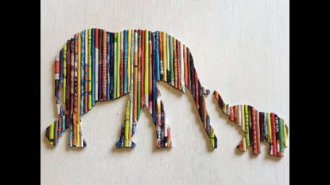
Introduce the concept of circular economy? Choose and discuss how a certain product you decide on could be reused so its life is extended? Determine where a meal you just had may have come from – list the meal items and then beside it how far away it may have come to get on to your plate. What processes were used to get it there - ie production, processing, packaging, transport and then distribution. How can you now address any leftovers?
Have a look at an imperfect veggie and discuss why it can be eaten, same as any other veggie and should not be thrown away or destroyed by the grocery store so it can still be purchased.
Make a newspaper butterfly using newspaper from the recycling bin, a twist tie and paint. There are several things this exercise can introduce as further activities. You may choose to make environmentally friendly paints from various flowers or fruits to paint the butterflies. Discuss the different kinds of pollinators and why they need to pollinate plants. Explore the relationship between pollinators and humans! If it is nice weather, consider to visit a domestic bee hive and see how to care for bee pollinators. You can also discuss what happens when toxics and poisons enter the biodiversity cycle that creates foods for different species or how invasive plant species can impact native plants and animal diversity and how to help remove invasive species.
Organize a scavenger hunt indoors to find 5 items that are being reused and 5 items in the recycling bin that could be reused another way to reuse them in your home – this could be something metal, something plastic, a box, something made of Styrofoam if that is collected.
Here are some more ideas for an indoor or outdoor hunt – visit https://www.greencalgary.org/ application/files/3415/8620/5110/Week2_Activity2_scavenger_hunt.pdf.
Borrow or bring your vermi-composter to the meeting or put one together at the meeting. Let children have a peek into the amazing world of worms and how they help recycle organic waste, turning it into healthy living soil. Discuss important life science concepts such as ecosystems, food webs and biodegradation and what is best to put into the bin, how often, and location.
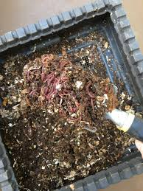
Bring some environmentally friendly cleaners to your meeting and discuss /demonstrate how they work - for instance, vinegar, baking soda, and borax. Discuss how other cleaners impact our environment, possibly our health, why simple products can do the job and save money too.
Organize a visit to a composter in someone’s backyard to see how it works. Note TREA has a demonstration site as one option. Discuss how compost prevents erosion, prevents plant dehydration, extends the growing season, provides nutrients for plants, stores minerals and neutralizes in the soil. Discuss how food scraps end up in garbage as unnecessarily waste.
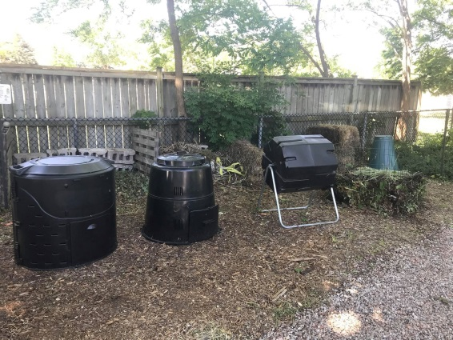
Have a free swap items exchange event. The families can help organize books, toys and clothing, it can even be a neighbourhood or block party event.
This activity should emphasize plastics do not break down easily. It could involve having a series of trials that compare the breakdown of paper and plastic items, for example, placing two types of bags under water, the paper one would become soft and start falling apart while the plastic bag would remain the same. Discussion could explore why plastics are so durable, thus adding to our landfills. Children could explore what retail stores have products more friendly to the Earth. The group could plan a visit to see what a waste free or waste friendly store has in stock and share the information with their families. Children could also be given cloth bags.
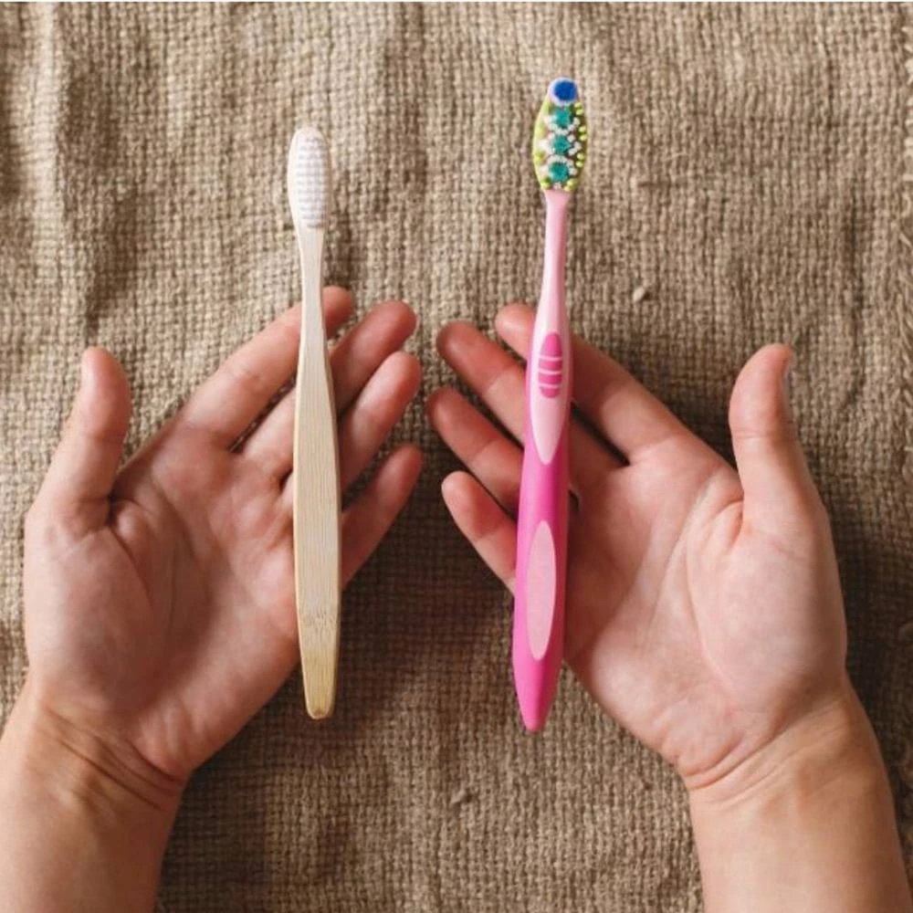
Children could make a collage of perceived ‘needs’ on one half of the page and ‘wants’ on the other. This can include toys, foods, clothing, etc. Discussion can involve what materials the ‘wants’ are made of and are these items actually necessary to make us happy, leading to how much waste goes to our landfill and how we can all cut back.
Contacting TREA
We appreciate your interest to use this material and welcome you to keep in touch.
If you have any questions, comments, or concerns, please do not hesitate to contact TREA:
In-person (call first) or by inquiry:
Grosvenor Lodge, 1017 Western Road, London, Ontario, N6G 1G5
By phone: (519) 645 2845 By email: info@trea.ca
Through our website: https:// www.trea.ca/

We again thank the Westminster College Foundation for supporting this program.

