GREEN FEST SCHEDULE OF EVENTS
Join us October 24 & 25 in the Vitali Student Lounge
for eco-poetry, philosophy, music, dance, art, activism, and all things green!

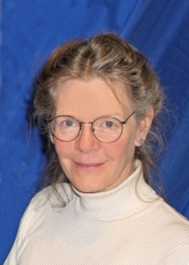
Thursday, Oct. 24, 7:00 – 10:00

7:00 Original Composition by Oliver Whitehead, performed by the King’s University College Chamber Choir, directed by Janet Loo

7:30 Reading by Governor General’s Award-Winning Poet, Jan Zwicky

8:30 Wine and Cheese Reception: Opening of Art Exhibition by Dr. Gloria Alvernaz-Mulcahy and Displays from Campus and Community Environmental Groups
Jan Zwicky

Friday, Oct 25, 10:00 – 4:00

All day: Eco-Fair featuring Campus and London Community Environmental Groups; Art Exhibition

1:00 Panel Discussion featuring Dr. Jan Zwicky, Prof. Miriam Love, and the King’s Philosophy Students’ Association

2:00 Poetry Reading featuring King’s Student & Alumni Poets and London Poets

3:00 Dance Workshop with Ruth Douthwright and
Kevin O’Connor

